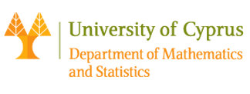

Seminar of the Department of Mathematics and Statistics, University of Cyprus

Room: 037, ΣΘΕΕ01. Date: 01/12/2017 Time: 13:00

Speaker: Alex Lubotzky ( Hebrew University)
Title : Ramanujan graphs and error correcting codes

Abstract:

While many of the classical codes are cyclic, a long standing conjecture
asserts that there are no `good' cyclic codes. In recent years,
interest in symmetric codes has been stimulated by Kaufman, Sudan,
Wigderson and others (where symmetric means that the acting group can
be any group). Answering their main question (and contrary to common
expectation), we show that there DO exist symmetric good codes. In
fact, our codes satisfy all the "golden standards" of coding theory.
Our construction is based on the Ramanujan graphs constructed by
Lubotzky-Samuels-Vishne as a special case of Ramanujan complexes.
The crucial point is that these graphs are edge transitive and not just
vertex transitive as in previous constructions of Ramanujan graphs.
These complexes are obtained as quotients of the Bruhat-Tits building modulo the action of suitable arithmetic groups. If time permits we will discuss the potential of these complexes and their cohomology to yield more
applications to coding theory. All notions will be explained.
Joint work with Tali Kaufman.

