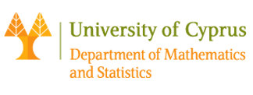

Seminar of the Department of Mathematics and Statistics, University of Cyprus

Room: 037, ΣΘΕΕ01. Date: 18/10/2017 Time: 11:00

Speaker : Tim Browning (University of Bristol)
Title : Diophantine equations: use and misuse

Abstract:

Integer solutions to polynomial equations have been studied since antiquity. In this talk I will discuss some of the surprising contexts that these equations arise, such as to quantum computing, before describing some recent work specific to cubic equations.

